Creating the payload:

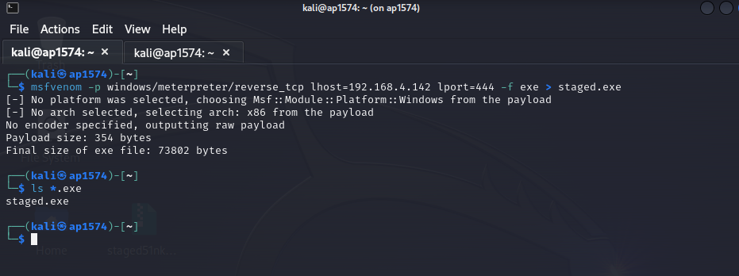

Opening the payload in windows machine

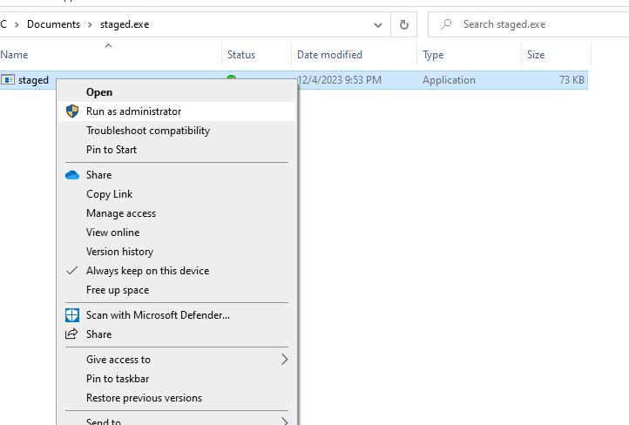

Showing we got access to the windows machine through msfconsole

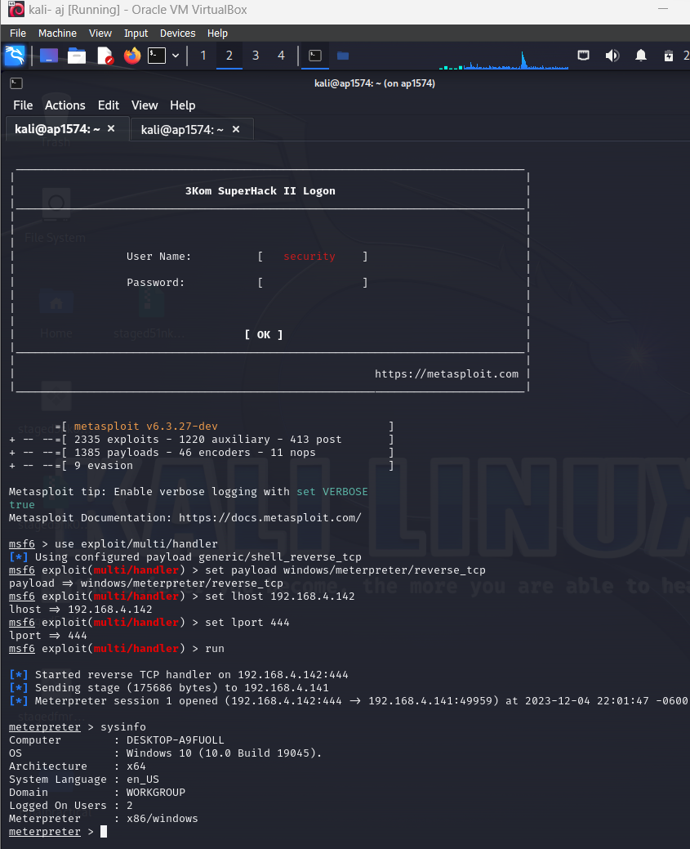

Creating the firewall

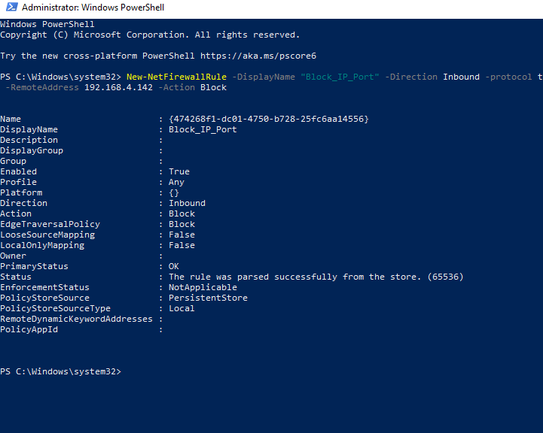

Retrying to check if we got the access

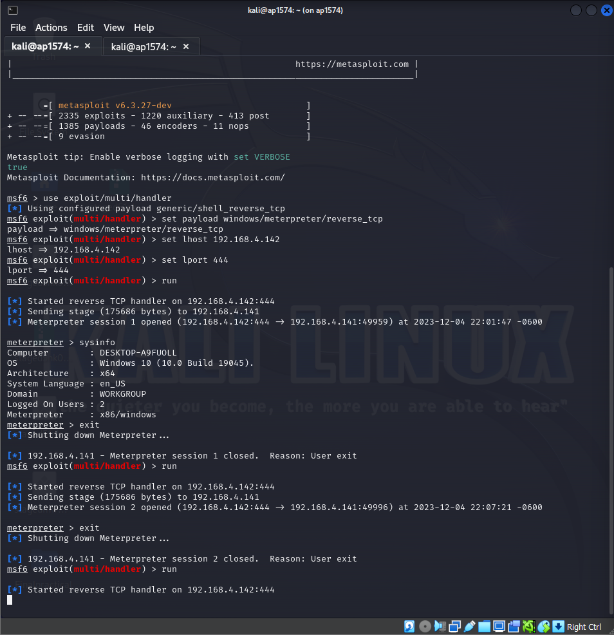

No, the conncection is left in open start no connection is established successfully.

Removing the rule

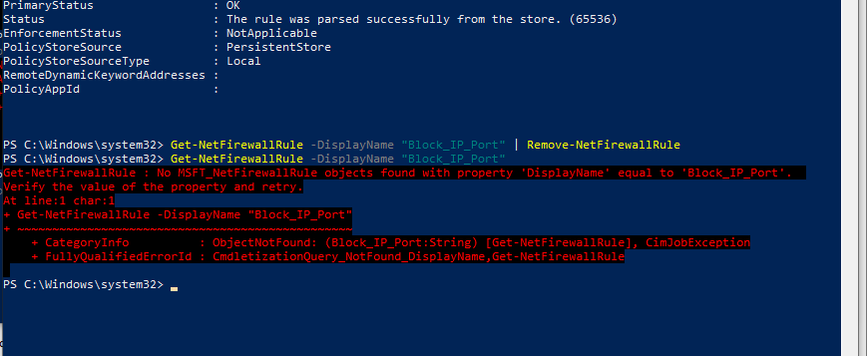

Confirming we got the access back

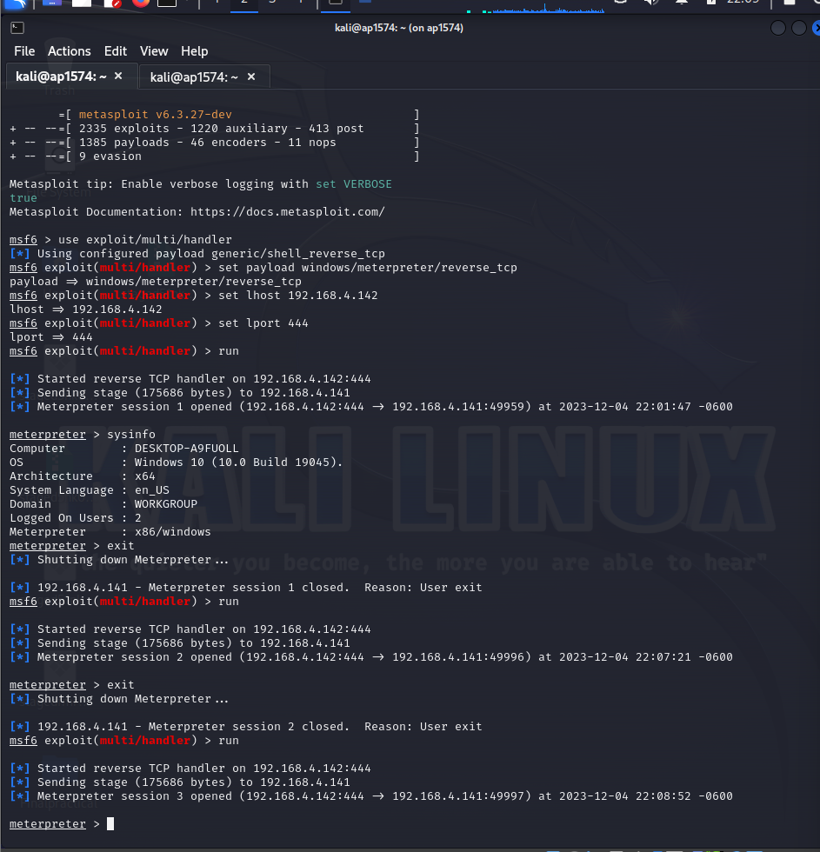

We can see , we go the access back